# Lab 03 – Applying CSS

### Aims

The aim of this lab is to investigate the information presentation of some popular websites, become familiar with the Firebug tool, then apply CSS to the **simple blog page** and **photo gallery page** developed in *Lab 02 – Implementing Wireframes in HTML.*

Use remaining lab time for your **group coursework**.

### Useful resources (these are both on moodle as well):

* HTML5 Cheat Sheet - <https://media-mediatemple.netdna-ssl.com/wp-content/uploads/images/html5-cheat-sheet/html5-cheat-sheet.pdf> (PDF)
* CSS Cheat Sheet - <http://media.smashingmagazine.com/wp-content/uploads/images/css3-cheat-sheet/css3-cheat-sheet.pdf>(PDF)

### Task One

We can learn a lot about CSS from investigating websites that we use commonly. Because the HTML and CSS files for websites are publicly visible, we can use the browser as a tool to inspect them. We also can discover how complex apparently simple website design can be. In the previous lab we used Firefox’s Inspector to view web pages from a 3D perspective to get a sense of their depth and tree-like nested structure.

In this task, we shall look at the structure of the code using the Firebug browser extension. You can read about it here:

* <http://getfirebug.com/>
* <http://en.wikipedia.org/wiki/Firebug_(software>)

**Install Firebug**

* Open Firefox
* Goto **Tools** menu or use the new menu on the right hand side 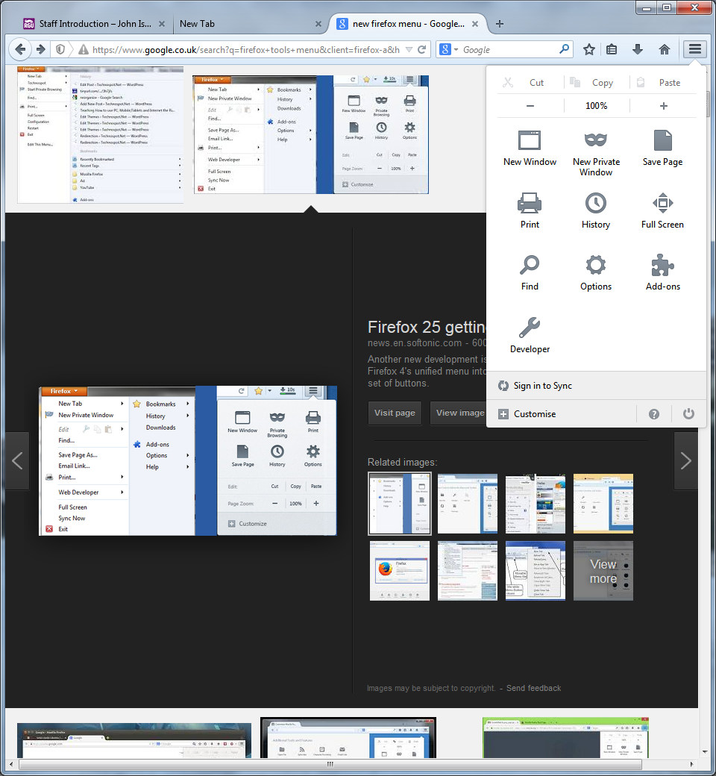 and choose **Add-Ons**
* Search for **Firebug**
* Click **Install** and **Restart** Firefox

*(You can do a similar thing with the built-in dev tools in chrome, however these are not labeled as clearly and you might find it difficult to follow if you are not sure what to do.)*

**Using Firebug**

* Goto [www.google.com](http://www.google.com) in Firefox
* Goto **Tools** / **Web Developer** / **Firebug** / **Open Firebug**
* **Or You can just right click the page and select inspect element with Firebug**
  + There should also be a shortcut icon on the browser window
  + 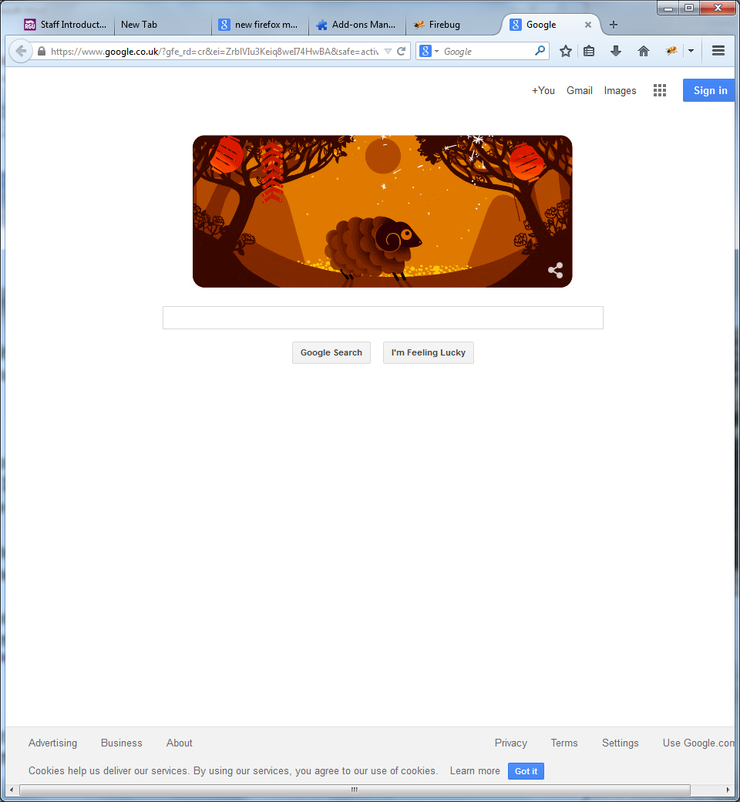

Add-on Shortcut

* The page should split into 3 panels
  + Web page view (*top*)
  + HTML code inspector (*bottom left*)
  + CScode inspector (*bottom right*)

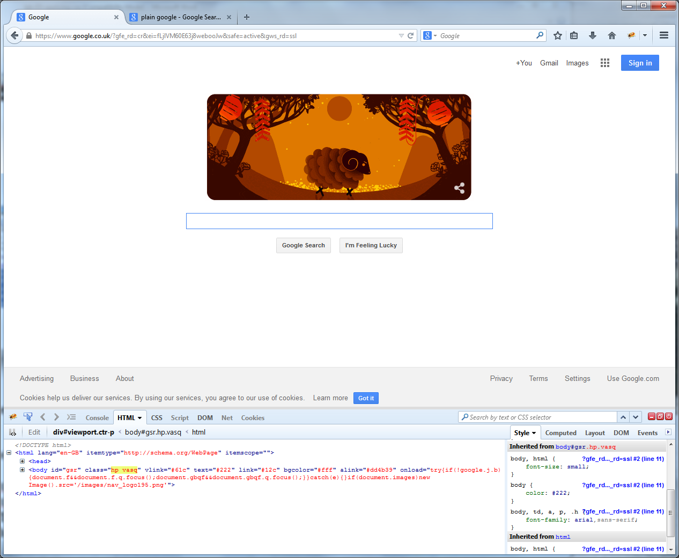

A

C

D

B

Figure 1: Firebug Interface

**Selecting Elements [A]**

To discover information directly about elements in a web page, we can use the select tool **[A]** to select and inspect them.

Use it to answer these questions:

1. What is the **type** of this element that contains the logo
2. What does the **title attribute** of this element contain
3. What is unusual about the Google Logo element (hint, think about the type of element and an alternative)
4. What happens when you move the mouseover the CSS rule for **element.style { background: url…}** in the bottom right panel.

**Browsing HTML Source [B]**

Rather than view the entire HTML source code for a page, we can use the code inspector **[B]** to navigate the page structure. If an element you mouseover in this panel is visible, you should see the top panel highlight that element in blue.

Use it to answer these questions:

1. How does Google load its CSS (embedded, or an external CSS file)?
   1. It’s possible that there is more than one answer here!
2. What are the IDs for the **navigation bar** at the top of the web page and for the rest of the **main content**?
3. How much padding is there at the top of the Google Logo?

**Editing CSS Live [C]**

A useful learning aspect of Firebug is editing the CSS of an existing site (or your own) to see the effects. The bottom right panel **[C]** allows you to edit CSS attribute values live, as well as add new ones. This can be a lot of fun, but more importantly allows you to tweak values and quickly see the results.

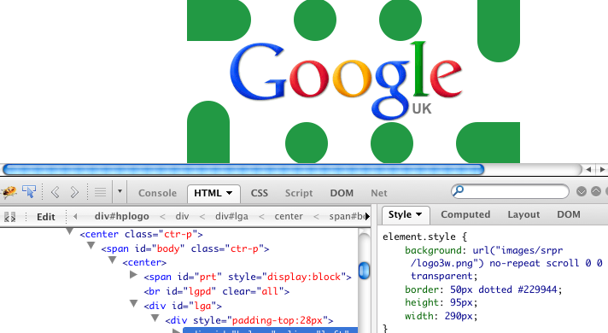

Figure 2: Google with messed up borders

Simply use the CSS editing panel to change as much of the Google homepage as possible. Think about adding borders of silly size, changing the colours of elements, or changing the logo image, or the text of the famous Google search buttons.

**Box Model [D]**

Finally, in Firebug the Box Model of any element can be explored by clicking Layout **[D]**. This is useful to discover just how the height, width, margins, padding and borders combine to create space around elements. Once again, you can edit values within the box model.

Choose a few elements and **alter the box model properties** using **[D]** then **check the CSS** code to see how the values were altered.

### Task Two: Add Style to a Blog

In Lab 02 we created a basic blog page. It was quite boring in terms of layout and style, and needs something to improve its user experience. Using the design knowledge and CSS rules encountered earlier, your task is the style the HTML produced last week.

Using PHPStorm open you blog.html file from last week,

Within the <head> tags in your blog.html you need to add the following line

<link rel="stylesheet" type="text/css" href="style.css">

This tells the Browser where the styles for our HTML is.

Now create a new file called **style.css** within the same folder as your **blog.html** file.

You should decide on and implement the following with CSS, use the example sin the lecture and the cheat sheet above to help you:

* **Colour Scheme**
  + use the colour wheel methods, or [www.colorlovers.com](http://www.colorlovers.com), or <https://color.adobe.com/create/color-wheel/>
  + pick a small set of colours
  + style elements such as **text**, e.g. #BlogPostTitle { color: #FF0000; } and **block elements**, e.g. #PageHeader { background-color: #EEEEEE: }
* **Layout**
  + introduce more sections and create a two-column or three column layout of elements
  + experiment with the box model of the major elements to create whitespace between them
* **Typography**
  + change the font sizes, use different fonts, etc
  + modify the line-spacing
* **Content**
  + you might want to create some more placeholder content (more blog entries, images, videos, links etc).

Remember to use **Firebug** on your own website to tweak and experiment.

### Task Three: Create the Photo Gallery Page Layout

Using the html code you developed for the wireframe in Task Three last week, try to recreate the layout indicated. You should aim to:

* Ensure you have appropriate ID and Class attributes to link the HTML and CSS code.
* Use Margins, Padding and Borders in CSS to visualise the HTML sections
* Include any extra HTML sections (div/section/etc) to organise the content of the page
* Create the main two column layout that separates the photo from the thumbnails
* Make the entire page content balance in the middle of the browser window.

Reminder of Photo Gallery Page Wireframe Layout



Once you are finished you need to test your site live on your Azure host. Because we have added a new file we need to ensure that it is added to our local GIT repository. Dead simple, just right click your project and select Git >Add.

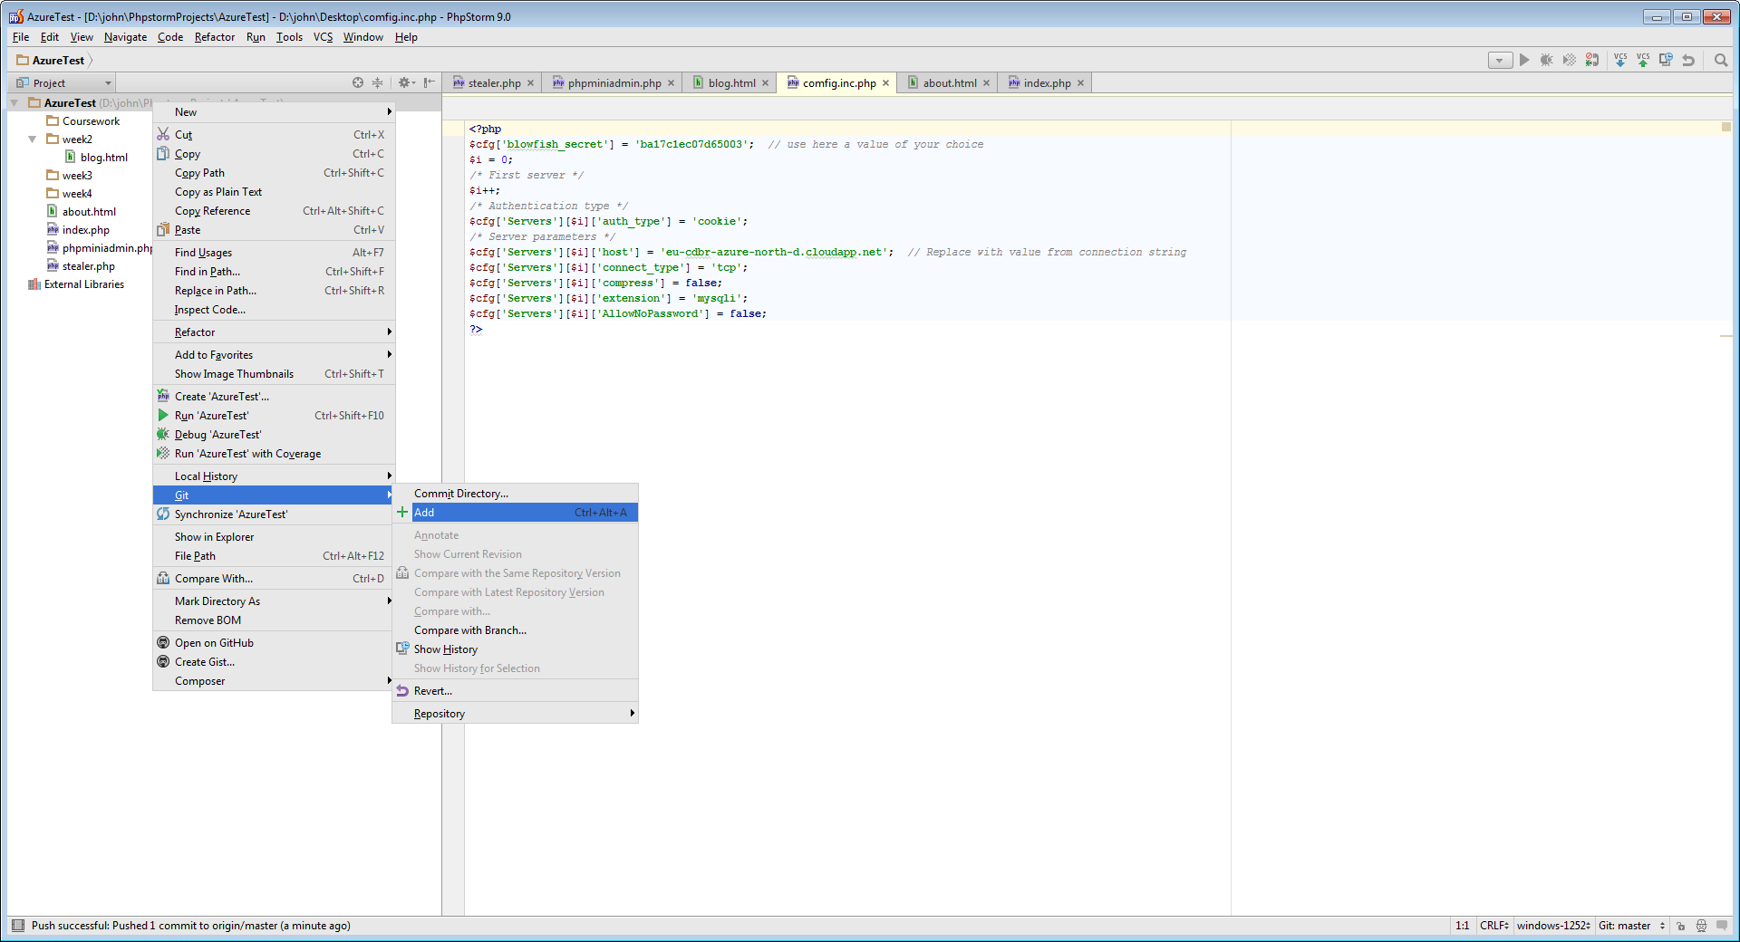

Once completed commit and push (Right click > Git > Commit) your code to GitHub, you can then visit your site and check that your live code functions just like your local code. Also because your code is now on GitHub it is all nicely backed up (again)!

### In the remaining time…

* Continue developing your web app concept with your groups using Google docs. Discuss the following questions:
  + What do we want to build?
  + What 3rd party data do we need from a web service (e.g. pictures / video, news, etc)?
  + What is our information architecture?
    - What is the **Context** of the web app?
    - Who are our **Users**?
    - What is the **Content**?